S.RAJESH KUMAR

*B.sc.Information Technology*

# PROFILE

Information technology student.

I consider my self a

responsible and orderly person.

I am looking foward for my first work

experience.

# CONTACT ME

9500534359

[Kumar38092@gmail.com](mailto:Kumar38092@gmail.com)

Vinayagar Kovil

Street,pichampalayam, Tirupur.

# EDUCATION

**BHARATHIAR UNIVERSITY**

*cherraan's arts science college, kangayam.*

*2021-2024*

# LANGUAGE

Native Tamil.

Advanced English.

# COMPUTER SKILLS

Java

Python

Microsoft Excel

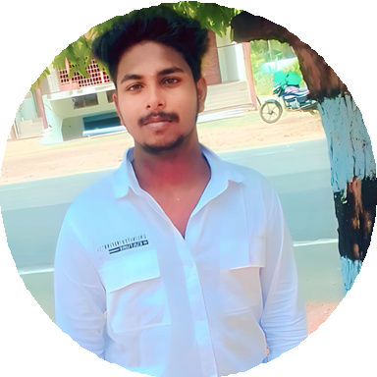

# SKILLS

Cricket editor

programming.